# Special notes

## Introduction

In this chapter we will discuss some special issues or things that are easy to know. It will just be a collection of extra knowledge randomly addressed and will be changed over time.

## PLC

When a PLC program is written and put into the Wago PLC itself it is necessary, especially for the outputs, that NavVision doesn’t have field tags attached. To prevent the PLC program as well as NavVision to address the output on the Wago, you do the following:

The rows in the sensorlist that hold the outputs that already are in use by the Wago PLC program, will need to be adjusted. First you add a “,PLC” after the module number in the column “Type” See the next figure:

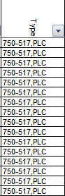

Figure 14‑1: PLC added

This way NavVision knows that the slice is in use by the Wago itself, but will show up in the Wago overview in NavVision see the next figure:

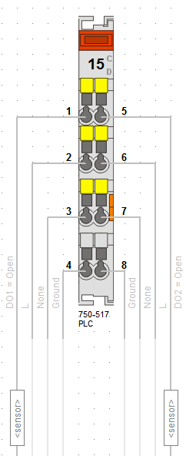

Figure 14‑2: Wago overview PLC

*: Leave the field column empty or it will interfere with the Wago PLC program.*

## Search

When you check the “sensorlist_generated” you will often find comments. Most of the time it will be that you used the same field-ID in different rows. When you find a comment, go to the column “Type” and copy the field-ID. Press CTRL-F and you get a window where you can search. Paste the copied field-ID and select “Find all”. Now you can scroll through the fields to see if you have used the same Field-ID on multiple rows. If you find it, repair the problem and it will be fixed.